Mitonuclear discordance in wolf spiders: Genomic Evidence for Species Integrity and Introgression

Vladislav Ivanov1*, Kyung Min Lee1, Marko Mutanen1

Suppotring Information

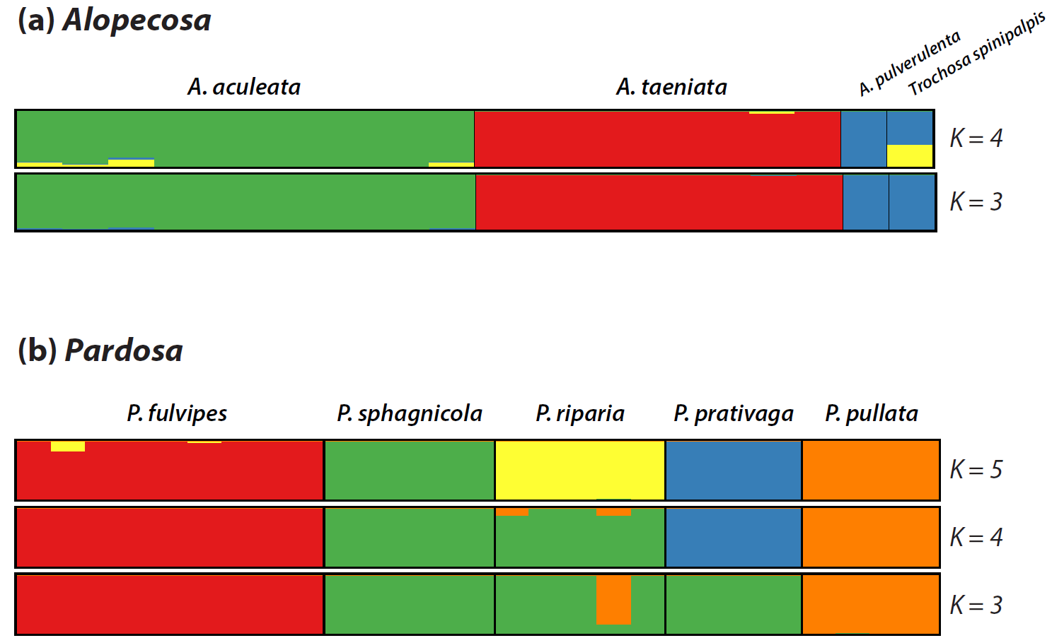

Figure S1. STRUCTURE analysis of *Alopecosa* and *Pardosa* groups.

We used admixture analysis implemented in STRUCTURE v.2.3.1 (Pritchard *et al.* 2000) using SNP frequency data to better visualize genomic variation between individuals. Ten replicates were run at each value of *K* between 3 and 4 for *Alopecosa* group and between 3 and 5 for *Pardosa* group. Each run had a burn-in of 10K generations followed by 20K generations of sampling. We used StrAuto to automate Structure processing of samples (Chhatre & Emerson 2017). Replicates were permuted in the program CLUMPP (Jakobsson & Rosenberg 2007), and the optimal *K* was inferred using the online resource Structure Harvester (Earl & vonHoldt 2012) according to the ad hoc ∆*K* statistics (Evanno *et al.* 2005), which is the second-order rate of change of the likelihood function. Structure results were visualized using the program DISTRUCT (Rosenberg 2004).

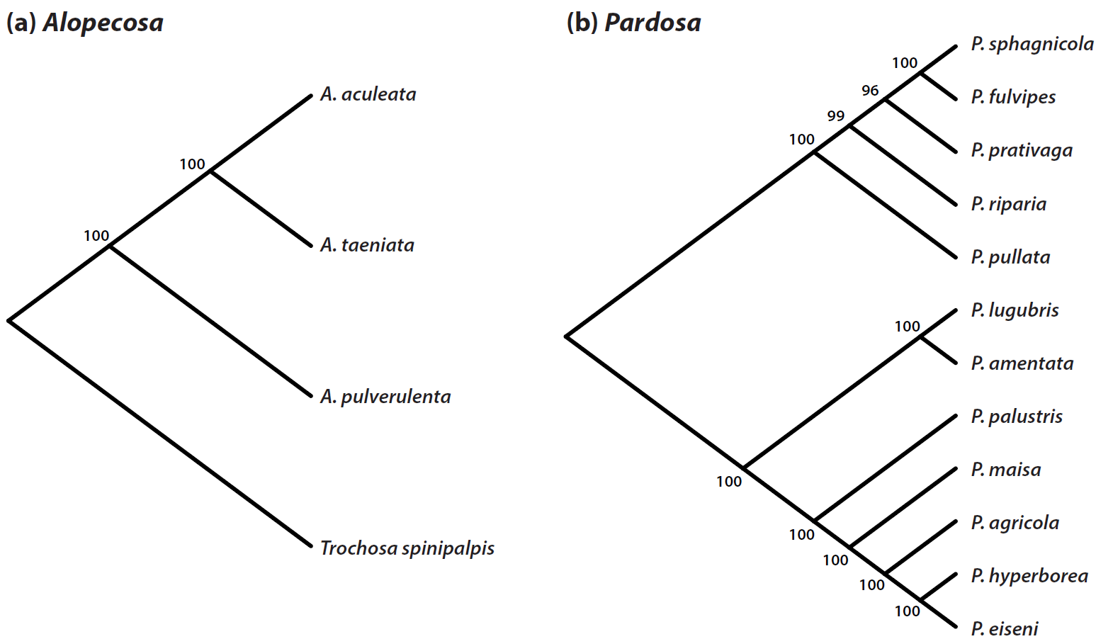

Figure S2. Spcies trees for *Alopecosa* and *Pardosa* groups calculated in SVDquartets

Species tree were also estimated in a coalescent framework using SNP data with the program SVDquartets (Chifman & Kubatko 2014) implemented in PAUP* (Swofford 2003). The SVDquartets analyses used the same set of biallelic SNPs (coded as nucleotides) and sub-sampled 500,000 quartets. Sampled quartets were assembled into a species tree using a variant of Quartet FM (Reaz *et al.* 2014), which is the implementation currently recommended by the developers of SVDquartets.



Figure S3. Neighbor-joining trees made in MEGA6 for endosymbiont sequences. Spider samples are marked by their ID number as in Table S1. Reference sequences are indicated with GenBank accession number. (a) – *Wolbachia*, Wsp; (b) – *Wolbachia*, Ftsz; (c) – *Rickettsia*; (d) – *Spiroplasma*. Numbers indicate bootstrap support values for each node

Table S1. Collection data summary for the specimens included in the ddRADseq run. Infected samples are indicated with superscript: *W* – *Wolbachia*, *R* – *Rickettsia*, *S* – *Spiroplasma*. Collectors: VI – Vladislav Ivanov, AK – Ari Kakko, MM – Marko Mutanen, TM – Timo Pajunen, MP – Mikko Pentinsaari. *NI* – not included in analysis due to low ddRADseq performance.

|  |  |  |  |  |  |  |
| --- | --- | --- | --- | --- | --- | --- |
| **Species** | **Sample ID** | **Collection sites** | **Collection date** | **Latitude** | **Longitude** | **Collector** |
| *NI Acantholycosa lignariaS* | UUI0063 | Finland, Kiiminki | 19.06.2015 | 65.1478 | 25.8383 | VI |
| *NI Acantholycosa lignaria* | UUI0064 | Finland, Oulanka, Puukkosuo | 06.08.2015 | 66.377659 | 29.307723 | VI |
| *Alopecosa aculeata* | UUI0002 | Finland, Oulu, Pilpajärvi | 21.06.2015 | 64.971346 | 25.793879 | VI |
| *Alopecosa aculeata* | UUI0003 | Finland, Kilpisjärvi, Siilasjärvi | 14.07.2015 | 69.081813 | 20.750465 | VI |
| *Alopecosa aculeata* | UUI0004 | Finland, Tvärminne | 12.06.2015 | 59.847283 | 23.210839 | VI |
| *Alopecosa aculeata* | UUI0005 | Finland, Tvärminne | 12.06.2015 | 59.847283 | 23.210839 | VI |
| *Alopecosa aculeata* | UUI0007 | Finland, Tvärminne | 10.06.2015 | 59.845209 | 23.204611 | VI |
| *Alopecosa aculeataW* | UUI0008 | Finland, Kuusamo, Jäkälämutka | 06.07.2015 | 66.290607 | 29.629349 | VI |
| *Alopecosa aculeata* | UUI0009 | Finland, Kilpisjärvi, Saana | 14.07.2015 | 69.057161 | 20.812779 | VI |
| *Alopecosa aculeata* | UUI0010 | Finland, Tvärminne | 12.06.2015 | 59.847283 | 23.210839 | VI |
| *Alopecosa aculeataR* | UUI0091 | Finland, Tvärminne | 06.06.2015 | 59.847283 | 23.210839 | VI |
| *Alopecosa aculeata* | UUI0092 | Finland, Tvärminne | 06.06.2015 | 59.847283 | 23.210839 | VI |
| *NI Alopecosa cuneata* | HLA156267 | Finland, Dragsfjärd, Rosala | 31.05.2006 | 59.851 | 22.4216 | TP |
| *NI Alopecosa fabrilis* | AKO_001642 | Finland, Hailouto, Poellae | 03.08.2012 | 64.964 | 24.703 | AK |
| *NI Alopecosa inquilina* | ZMH107154 | Finland, Helsinki, Talosaari | 09.06.2008 | 60.2402 | 25.2028 | TP |
| *NI Alopecosa pinetorumS* | ZMH76219 | Finland, Sodankylä | 16.06.2008 | 67.4022 | 26.695 | TP |
| *Alopecosa pulverulenta* | UUI0021 | Finland, Hanko, Högholmen | 11.06.2015 | 59.829552 | 23.142492 | VI |
| *Alopecosa taeniata* | UUI0011 | Finland, Oulanka, Puukkosuo | 06.08.2015 | 66.377659 | 29.307723 | VI |
| *Alopecosa taeniataWR* | UUI0012 | Finland, Kiiminki | 02.07.2015 | 65.1478 | 25.8383 | VI |
| *Alopecosa taeniata* | UUI0013 | Finland, Kiiminki | 02.07.2015 | 65.1478 | 25.8383 | VI |
| *Alopecosa taeniataW* | UUI0014 | Finland, Kiiminki | 02.07.2015 | 65.1478 | 25.8383 | VI |
| *Alopecosa taeniata* | UUI0015 | Finland, Kiiminki | 02.07.2015 | 65.1478 | 25.8383 | VI |
| *Alopecosa taeniataW* | UUI0016 | Finland, Kiiminki | 02.07.2015 | 65.1478 | 25.8383 | VI |
| *Alopecosa taeniataW* | UUI0017 | Finland, Kiiminki | 08.06.2015 | 65.1478 | 25.8383 | VI |
| *Alopecosa taeniata* | UUI0018 | Finland, Kiiminki | 06.07.2015 | 65.1478 | 25.8383 | VI |
| *NI Alopecosa taeniata* | UUI0019 | Finland, Kiiminki | 01.07.2015 | 65.1478 | 25.8383 | VI |
| *NI Alopecosa taeniataS* | UUI0020 | Finland, Kiiminki | 06.07.2015 | 65.1478 | 25.8383 | VI |
| *NI Arctosa alpigena* | UUI0083 | Finland, Oulu | 06.07.2015 | 65.215994 | 26.278575 | VI |
| *NI Arctosa cinerea* | AKO_001058 | Finland, Parainen, Knapulen | 18.06.2014 | 6.13 | 22.182 | MP |
| *NI Arctosa leopardus* | HLA156268 | Finland, Dragsfjärd | 31.05.2006 | 59.8726 | 22.5259 | TP |
| *NI Arctosa perita* | HLA156266 | Finland, Tvärminne, Örnholmen | 30.06.2014 | 59.8336 | 23.1551 | TP |
| *NI Aulonia albimana* | AKO_01149 | Finland, Parainen, Knapulen | 06.06.2011 | 6.13 | 22.182 | MP |
| *NI Hygrolycosa rubrofasciata* | UUI0065 | Finland, Oulu, Lylyjärvi | 08.06.2015 | 64.983577 | 25.668103 | AK |
| *Pardosa lugubris* | UUI0068 | Finland, Kiiminki | 18.06.2014 | 65.1478 | 25.8383 | VI |
| *NI Pardosa agrestis* | AKO_001159 | Finland, Paraisen, Knapuloen | 06.07.2015 | 60.13 | 22.182 | MP |
| *Pardosa agricola* | UUI0074 | Finland, Kuusamo, Jäkälämutka | 08.06.2015 | 66.290607 | 29.629349 | VI |
| *Pardosa amentataWR* | UUI0069 | Finland, Kiiminki | 06.07.2015 | 65.1478 | 25.8383 | VI |
| *NI Pardosa atrata* | UUI0067 | Finland, Oulu | 14.07.2015 | 65.215994 | 26.278575 | VI |
| *Pardosa eiseni* | UUI0072 | Finland, Kilpisjärvi | 06.06.2011 | 69.056241 | 20.796986 | VI |
| *NI Pardosa fulvipes* | UUI0031 | Finland, Oulu, Lylyjärvi | 28.07.2010 | 64.983577 | 25.668103 | AK |
| *NI Pardosa fulvipes* | UUI0032 | Finland, Oulu, Hietasaari | 08.06.2015 | 65.019 | 25.424 | AK |
| *Pardosa fulvipes* | UUI0033 | Finland, Tvärminne | 11.06.2015 | 59.843292 | 23.212050 | VI |
| *Pardosa fulvipes* | UUI0034 | Finland, Tvärminne | 11.06.2015 | 59.843292 | 23.212050 | VI |
| *Pardosa fulvipes* | UUI0035 | Finland, Tvärminne | 11.06.2015 | 59.843292 | 23.212050 | VI |
| *Pardosa fulvipes* | UUI0036 | Finland, Tvärminne | 03.07.2015 | 59.843292 | 23.212050 | VI |
| *Pardosa fulvipes* | UUI0037 | Finland, Oulu, Kaijonlahti | 03.07.2015 | 65.064433 | 25.490416 | VI |
| *Pardosa fulvipes* | UUI0038 | Finland, Oulu, Kaijonlahti | 03.07.2015 | 65.064433 | 25.490416 | VI |
| *Pardosa fulvipes* | UUI0039 | Finland, Oulu, Kaijonlahti | 03.07.2015 | 65.064433 | 25.490416 | VI |
| *Pardosa fulvipes* | UUI0040 | Finland, Oulu, Kaijonlahti | 14.07.2015 | 65.064433 | 25.490416 | VI |
| *Pardosa hyperborea* | UUI0066 | Finland, Oulu, Kaijonlahti | 25.07.2013 | 69.057161 | 20.812779 | VI |
| *NI Pardosa lapponica* | AKO_001650 | Finland, Kilpisjärvi, Saana | 08.06.2015 | 69,082 | 21,538 | AK |
| *Pardosa maisa* | UUI0071 | Finland, Enontekio, Iso-Jehkas | 19.06.2013 | 65.1478 | 25.8383 | VI |
| *NI Pardosa nigriceps* | ZMH131503 | Finland, Kiiminki | 29.05.2011 | 60.248 | 20.8042 | TP |
| *NI Pardosa paludicola* | UUI0073 | Finland, Kumlinge, Nöthholm | 14.07.2015 | 65.337 | 25.685 | AK |
| *Pardosa palustris* | UUI0070 | Finland, Karjalankylä | 08.07.2012 | 69.056241 | 20.796986 | VI |
| *NI Pardosa plumipes* | ZMH122148 | Finland, Kilpisjärvi | 11.06.2015 | 64.4135 | 24.0506 | TP |
| *NI Pardosa prativaga* | UUI0052 | Finland, Pyhäjoki, Rööninlisu | 11.06.2015 | 59.843292 | 23.212050 | VI |
| *Pardosa prativaga* | UUI0054 | Finland, Tvärminne | 06.08.2015 | 59.843292 | 23.212050 | VI |
| *NI Pardosa prativaga* | UUI0055 | Finland, Tvärminne | 11.06.2015 | 66.377659 | 29.307723 | VI |
| *NI Pardosa prativaga* | UUI0057 | Finland, Oulanka, Puukkosuo | 11.06.2015 | 59.829552 | 23.142492 | VI |
| *Pardosa prativaga* | UUI0058 | Finland, Hanko, Högholmen | 08.06.2015 | 59.829552 | 23.142492 | VI |
| *Pardosa prativaga* | UUI0061 | Finland, Hanko, Högholmen | 08.06.2015 | 59.843292 | 23.212050 | VI |
| *Pardosa prativaga* | UUI0062 | Finland, Tvärminne | 15.06.2015 | 59.843292 | 23.212050 | VI |
| *NI Pardosa pullata* | UUI0027 | Finland, Tvärminne | 11.06.2015 | 59.843292 | 23.212050 | VI |
| *NI Pardosa pullata* | UUI0028 | Finland, Tvärminne | 11.06.2015 | 59.843292 | 23.212050 | VI |
| *Pardosa pullata* | UUI0029 | Finland, Tvärminne | 11.06.2015 | 59.843292 | 23.212050 | VI |
| *Pardosa pullata* | UUI0030 | Finland, Tvärminne | 11.06.2015 | 59.843292 | 23.212050 | VI |
| *Pardosa pullata* | UUI0056 | Finland, Kiiminki | 19.06.2015 | 59.843292 | 23.212050 | VI |
| *Pardosa riparia* | UUI0051 | Finland, Kiiminki | 19.06.2015 | 65.1478 | 25.8383 | VI |
| *Pardosa riparia* | UUI0084 | Finland, Kiiminki | 19.06.2015 | 65.1478 | 25.8383 | VI |
| *NI Pardosa riparia* | UUI0085 | Finland, Kiiminki | 31.07.2011 | 65.1478 | 25.8383 | VI |
| *Pardosa riparia* | UUI0086 | Finland, Kiiminki | 26.06.2015 | 65.1478 | 25.8383 | AK |
| *NI Pardosa ripariaS* | UUI0087 | Finland, Kiiminki | 26.06.2015 | 65.1478 | 25.8383 | VI |
| *NI Pardosa ripariaS* | UUI0088 | Finland, Kiiminki | 19.06.2015 | 65.1478 | 25.8383 | VI |
| *Pardosa riparia* | UUI0089 | Finland, Kiiminki | 19.06.2015 | 65.1478 | 25.8383 | VI |
| *Pardosa riparia* | UUI0090 | Finland, Kiiminki | 19.06.2015 | 65.1478 | 25.8383 | VI |
| *NI Pardosa schenkeli* | AKO_001625 | Finland, Kiiminki | 02.07.2015 | 64.964 | 24.703 | AK |
| *Pardosa sphagnicola* | UUI0025 | Finland, Kiiminki | 11.06.2015 | 65.1478 | 25.8383 | VI |
| *NI Pardosa sphagnicola* | UUI0041 | Finland, Hailouto, Poellae | 09.06.2015 | 65.1478 | 25.8383 | VI |
| *Pardosa sphagnicolaS* | UUI0042 | Finland, Kiiminki | 11.06.2015 | 65.1478 | 25.8383 | VI |
| *Pardosa sphagnicola* | UUI0043 | Finland, Kiiminki | 19.06.2015 | 66.377659 | 29.307723 | VI |
| *NI Pardosa sphagnicola* | UUI0044 | Finland, Kiiminki | 19.06.2015 | 59.843292 | 23.212050 | VI |
| *NI Pardosa sphagnicolaWR* | UUI0045 | Finland, Oulanka, Puukkosuo | 01.07.2015 | 65.1478 | 25.8383 | VI |
| *Pardosa sphagnicola* | UUI0046 | Finland, Tvärminne | 01.07.2015 | 65.1478 | 25.8383 | VI |
| *Pardosa fulvipes* | UUI0049 | Finland, Kiiminki | 08.06.2015 | 65.064433 | 25.490416 | VI |
| *Pardosa sphagnicola* | UUI0050 | Finland, Kiiminki | 03.07.2015 | 65.064433 | 25.490416 | VI |
| *Pardosa pullata* | UUI0060 | Finland, Oulu, Kaijonlahti | 16.08.2011 | 59.843292 | 23.212050 | VI |
| *NI Pirata piraticus* | UUI0079 | Finland, Oulu, Kaijonlahti | 19.06.2015 | 65.064433 | 25.490416 | VI |
| *NI Pirata piscatorius* | UUI0082 | Finland, Kiiminki, Huttukylä | 29.06.2015 | 65.1478 | 25.8383 | AK |
| *NI Pirata uliginosus* | UUI0081 | Finland, Kiiminki | 08.06.2015 | 65.1478 | 25.8383 | VI |
| *NI Piratula hygrophilaR* | UUI0080 | Finland, Kiiminki | 24.05.2015 | 65.1478 | 25.8383 | VI |
| *NI Piratula insularis* | UUI0078 | Finland, Kiiminki | 08.06.2015 | 65.1478 | 25.8383 | VI |
| *NI Pisaura mirabilis* | UUI0093 | Finland, Husö | 19.06.2015 | 60.2411 | 25.1998 | MM |
| *Trochosa spinipalpis* | UUI0076 | Finland, Kiiminki | 19.06.2015 | 65.1478 | 25.8383 | VI |
| *NI Xerolycosa nemoralis* | UUI0077 | Finland, Kiiminki | 06.08.2015 | 65.1478 | 25.8383 | VI |

Table S2. The protocols for endosymbiont sequencing.

|  |  |  |  |  |  |
| --- | --- | --- | --- | --- | --- |
| Species | Gene | Primers | Primers 5’ to 3’ | PCR | Reference |
| *Rickettsia* | 16S | RKlongF  RKlong R | ACGTGGGAATCTACCCATCA  TAGCCTAGATGACCGCCTTC | 95°C for 2 min,  40 cycles  92°C for 30 s,  60°C for 30 s,  72°C for 30 s | Curry et al., 2015 |
| *Cardinium* | 16S | ChF  ChR | TACTGTAAGAATAAGCACCGGC  GTGGATCACTTAACGCTTTCG | 94°C for 3 min,  40 cycles  94°C for 30 s,  56°C for 45 s,  72°C for 1 min | Curry et al., 2015 |
| *Spiroplasma* | 16S | Spits-J04  Spits-N55 | GCCAGAAGTCAGTGTCCTAACCG  ATTCCAAGGCATCCACCATACG | 92°C for 3 min,  40 cycles  92°C for 30 s,  55°C for 45 s,  72°C for 1 min | Jin et al., 2013 |
| *Wolbachia* | FtsZ | FtsZ-F  FtsZ-R | TACTGACTGTTGGAGTTGTAACTAAGCCGT  TGCCAGTTGCAAGAACAGAAACTCTAACTC | 92°C for 3 min,  40 cycles  92°C for 30 s,  55°C for 45 s,  72°C for 1 min | Briag et al., 1998 |
| *Wolbachia* | Wsp | Wsp-F  Wsp-R | TGGTCCAATAAGTGATGAAGA AAC  AAAAATTAAACGCTACTC CA | 92°C for 3 min,  40 cycles  92°C for 30 s,  55°C for 45 s,  72°C for 1 min | Zha et al., 2014 |

Table S3 Distribution of endosymbionts among studied species. Other refer to 35 specimens of different Lycosidae species that were tested for endosymbiont presence.

|  |  |  |  |  |  |
| --- | --- | --- | --- | --- | --- |
| **Species** | **Number of samples** | ***Wolbachia*** | ***Spiroplasma*** | ***Cardinium*** | ***Rickettsia*** |
| ***Alopecosa aculeata*** | 10 | **1** | 0 | 0 | **1** |
| ***Alopecosa taeniata*** | 10 | **4** | **1** | 0 | **2** |
| ***Pardosa fulvipes*** | 10 | 0 | 0 | 0 | 0 |
| ***Pardosa prativaga*** | 7 | 0 | 0 | 0 | 0 |
| ***Pardosa pullata*** | 6 | 0 | 0 | 0 | 0 |
| ***Pardosa riparia*** | 8 | 0 | **2** | 0 | 0 |
| ***Pardosa sphagnicola*** | 9 | **1** | **1** | 0 | **1** |
| **Other** | 35 | **1** | **2** | 0 | **2** |
| **Total** | 95 | 7 | 6 | 0 | 6 |
| **Percentage** | 100% | 7.4% | 6.3% | 0% | 6.3% |

Table S4. Patterson’s four-taxon D-statistic test results showing significant replicates for introgression in *Alopecosa* and *Pardosa*.

|  |  |  |  |  |  |  |  |  |  |
| --- | --- | --- | --- | --- | --- | --- | --- | --- | --- |
| P1 | P2 | P3 | D | Std(D) | **Z** | ABBA | BABA | No. loci | pdisc |
| ***Alopecosa* group** | |  |  |  |  |  |  |  |  |
| UUI0004_Aacul | UUI0091_Aacul | UUI0017_Ataen | -1.00 | 0.07 | **14.18** | 23.00 | 0.00 | 12 | 0.33 |
| UUI0004_Aacul | UUI0008_Aacul | UUI0017_Ataen | -0.92 | 0.15 | **6.07** | 22.75 | 1.00 | 28 | 0.25 |
| UUI0004_Aacul | UUI0008_Aacul | UUI0012_Ataen | -0.80 | 0.14 | **5.59** | 4.50 | 0.50 | 23 | 0.17 |
| UUI0004_Aacul | UUI0092_Aacul | UUI0015_Ataen | 0.83 | 0.17 | **4.79** | 5.50 | 60.50 | 23 | 0.48 |
| UUI0003_Aacul | UUI0008_Aacul | UUI0015_Ataen | 0.86 | 0.18 | **4.75** | 3.50 | 45.75 | 44 | 0.27 |
| UUI0004_Aacul | UUI0005_Aacul | UUI0021_Apulv | -0.75 | 0.18 | **4.18** | 14.00 | 2.00 | 24 | 0.25 |
| ***Pardosa* group** |  |  |  |  |  |  |  |  |  |
| UUI0034_Pfulv | UUI0040_Pfulv | UUI0025_Pspha | -1.00 | 0.08 | **12.95** | 0.00 | 15.00 | 38 | 0.13 |
| UUI0034_Pfulv | UUI0040_Pfulv | UUI0046_Pspha | -0.81 | 0.12 | **6.87** | 3.00 | 28.75 | 76 | 0.20 |
| UUI0034_Pfulv | UUI0038_Pfulv | UUI0046_Pspha | -1.00 | 0.20 | **5.04** | 0.00 | 7.25 | 20 | 0.15 |
| UUI0037_Pfulv | UUI0038_Pfulv | UUI0046_Pspha | -0.78 | 0.18 | **4.35** | 4.00 | 33.00 | 70 | 0.19 |
| UUI0033_Pfulv | UUI0040_Pfulv | UUI0051_Pripa | -0.64 | 0.12 | **5.44** | 18.75 | 85.75 | 282 | 0.17 |
| UUI0035_Pfulv | UUI0040_Pfulv | UUI0089_Pripa | 1.00 | 0.19 | **5.37** | 3.00 | 0.00 | 28 | 0.11 |
| UUI0034_Pfulv | UUI0049_Pfulv | UUI0086_Pripa | -0.84 | 0.16 | **5.23** | 2.50 | 28.50 | 46 | 0.20 |
| UUI0036_Pfulv | UUI0039_Pfulv | UUI0084_Pripa | -0.72 | 0.14 | **5.23** | 15.00 | 91.50 | 181 | 0.23 |
| UUI0037_Pfulv | UUI0038_Pfulv | UUI0051_Pripa | -0.85 | 0.20 | **4.26** | 1.50 | 18.50 | 44 | 0.20 |
| UUI0034_Pfulv | UUI0037_Pfulv | UUI0086_Pripa | -0.80 | 0.20 | **4.05** | 2.00 | 18.00 | 73 | 0.12 |
| UUI0033_Pfulv | UUI0034_Pfulv | UUI0084_Pripa | -0.51 | 0.13 | **4.04** | 6.50 | 20.00 | 55 | 0.20 |
| UUI0037_Pfulv | UUI0038_Pfulv | UUI0061_Pprat | -0.76 | 0.15 | **5.06** | 7.50 | 56.00 | 55 | 0.27 |
| UUI0033_Pfulv | UUI0038_Pfulv | UUI0061_Pprat | -0.87 | 0.18 | **4.90** | 2.50 | 36.00 | 50 | 0.26 |
| UUI0038_Pfulv | UUI0049_Pfulv | UUI0058_Pprat | 0.64 | 0.15 | **4.15** | 13.50 | 3.00 | 23 | 0.22 |
| UUI0035_Pfulv | UUI0036_Pfulv | UUI0029_Ppull | -0.59 | 0.10 | **5.91** | 9.25 | 35.75 | 204 | 0.15 |
| UUI0038_Pfulv | UUI0040_Pfulv | UUI0030_Ppull | 1.00 | 0.20 | **5.04** | 4.00 | 0.00 | 26 | 0.12 |
| UUI0042_Pspha | UUI0025_Pspha | UUI0039_Pfulv | 1.00 | 0.14 | **7.32** | 4.50 | 0.00 | 21 | 0.19 |
| UUI0046_Pspha | UUI0025_Pspha | UUI0039_Pfulv | 0.74 | 0.14 | **5.50** | 37.00 | 5.50 | 65 | 0.31 |
| UUI0043_Pspha | UUI0025_Pspha | UUI0035_Pfulv | 0.52 | 0.13 | **4.18** | 47.75 | 15.00 | 125 | 0.24 |
| UUI0046_Pspha | UUI0025_Pspha | UUI0034_Pfulv | 0.97 | 0.25 | **3.86** | 14.50 | 0.25 | 27 | 0.19 |
| UUI0046_Pspha | UUI0050_Pspha | UUI0084_Pripa | 0.73 | 0.14 | **5.20** | 28.75 | 4.50 | 90 | 0.13 |
| UUI0046_Pspha | UUI0025_Pspha | UUI0086_Pripa | 0.72 | 0.15 | **4.89** | 18.50 | 3.00 | 45 | 0.22 |
| UUI0042_Pspha | UUI0043_Pspha | UUI0051_Pripa | 0.63 | 0.13 | **4.79** | 41.25 | 9.25 | 97 | 0.25 |
| UUI0086_Pripa | UUI0089_Pripa | UUI0037_Pfulv | 1.00 | 0.09 | **11.23** | 6.00 | 0.00 | 17 | 0.24 |
| UUI0086_Pripa | UUI0090_Pripa | UUI0034_Pfulv | -0.91 | 0.18 | **4.94** | 1.00 | 20.50 | 33 | 0.21 |
| UUI0086_Pripa | UUI0089_Pripa | UUI0046_Pspha | 1.00 | 0.19 | **5.23** | 3.50 | 0.00 | 18 | 0.17 |
| UUI0086_Pripa | UUI0090_Pripa | UUI0042_Pspha | -0.85 | 0.20 | **4.30** | 1.50 | 19.00 | 33 | 0.21 |
| UUI0051_Pripa | UUI0084_Pripa | UUI0058_Pprat | -1.00 | 0.12 | **8.23** | 0.00 | 6.25 | 30 | 0.13 |
| UUI0051_Pripa | UUI0084_Pripa | UUI0061_Pprat | -0.88 | 0.12 | **7.47** | 3.50 | 54.00 | 75 | 0.15 |
| UUI0084_Pripa | UUI0089_Pripa | UUI0058_Pprat | -0.88 | 0.19 | **4.68** | 0.25 | 3.75 | 7 | 0.43 |
| UUI0051_Pripa | UUI0086_Pripa | UUI0058_Pprat | 0.90 | 0.22 | **4.14** | 18.00 | 1.00 | 33 | 0.15 |
| UUI0084_Pripa | UUI0089_Pripa | UUI0061_Pprat | 0.93 | 0.25 | **3.78** | 19.25 | 0.75 | 14 | 0.21 |
| UUI0054_Pprat | UUI0058_Pprat | UUI0090_Pripa | -0.86 | 0.11 | **7.95** | 1.75 | 22.50 | 71 | 0.24 |
| UUI0029_Ppull | UUI0060_Ppull | UUI0033_Pfulv | -0.57 | 0.13 | **4.29** | 20.00 | 72.00 | 251 | 0.18 |
| UUI0029_Ppull | UUI0060_Ppull | UUI0042_Pspha | -0.77 | 0.13 | **5.91** | 2.50 | 19.00 | 49 | 0.31 |
| UUI0029_Ppull | UUI0056_Ppull | UUI0046_Pspha | -0.80 | 0.16 | **5.03** | 2.50 | 22.50 | 51 | 0.24 |
| UUI0029_Ppull | UUI0056_Ppull | UUI0051_Pripa | -1.00 | 0.21 | **4.68** | 0.00 | 10.50 | 37 | 0.08 |
| UUI0029_Ppull | UUI0060_Ppull | UUI0089_Pripa | 0.79 | 0.20 | **4.04** | 8.50 | 1.00 | 13 | 0.46 |

D-statistic values (D) and the standard deviation (Std(D)) are given for each test. ABBA, BABA: the number of alleles that support each pattern (the fractions are due to heterozygosity). No. loci: the number of loci analyzed in each test; pdisc: the percentage of discordance. Z-scores that are statistically significant after conversion to a two-tailed p-value and using α = 0.01 as a conservative cutoff for significance.